Xv6 Development in VirtualBox
1. Download and install VirtualBox.
2. Download the appliance image  (warning: 2.6GB).
3. Open VirtualBox and import the image.
4. Recommended: Open Settings and set the following (according to the capabilities of your machine).
System -> Processor -> set CPUs to 2
Display -> set Video Memory to 32MB and check Enable 3D Acceleration
5. Start the appliance.
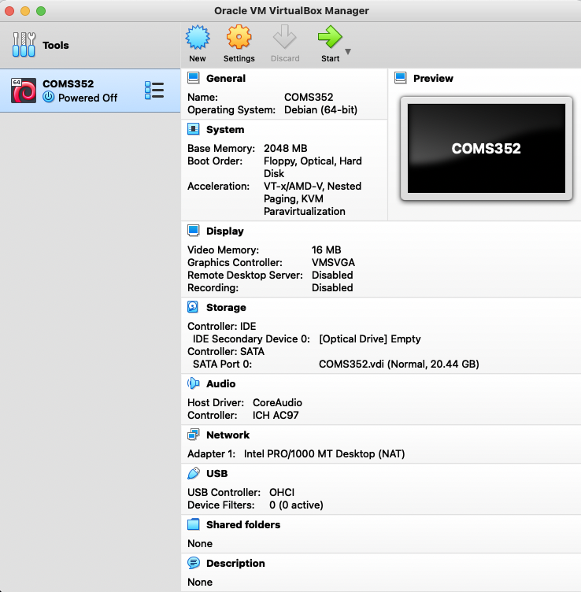
Some students have reported the error message "Oh no! Something has gone wrong" during booting. There has been success by enabling 3D acceleration.
6. Login with password: password.
7. Select activities and open vscode.

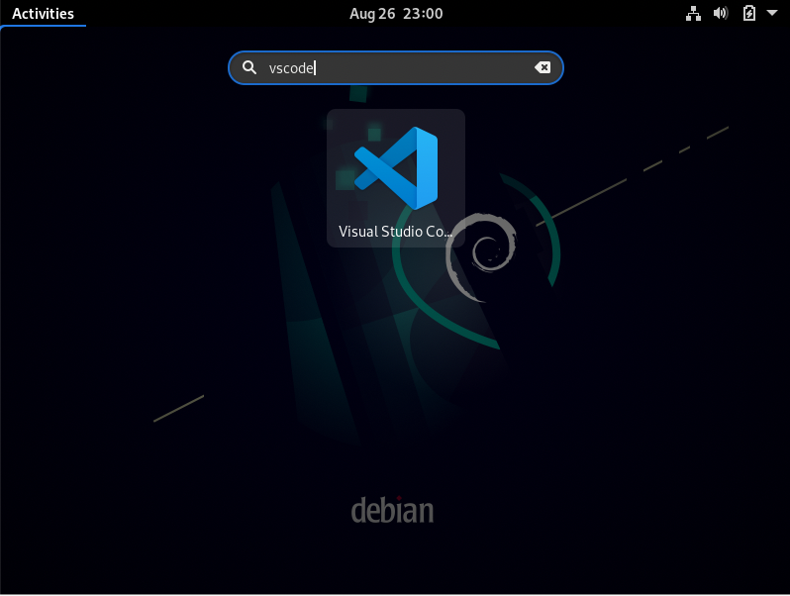
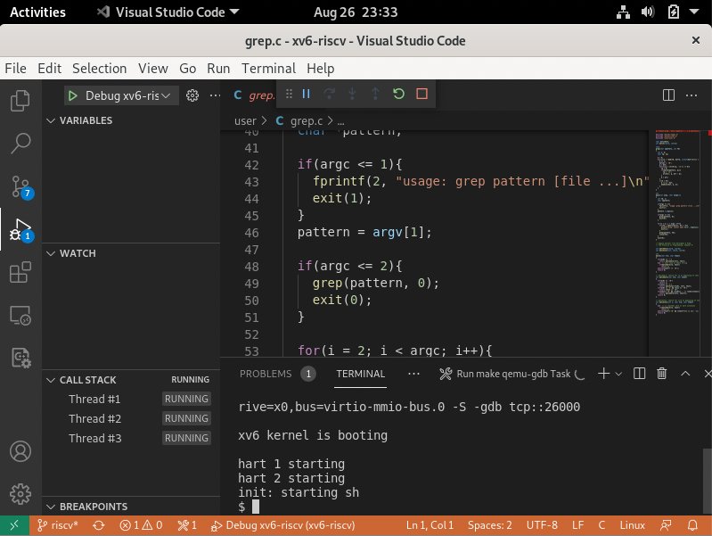
The project file is in the home directory on the virtual machine. You can submit work using FireFox on the virtual machine or you may find this helpful: https://carleton.ca/scs/tech-support/virtual-machines/transferring-files-to-and-from-virtual-machines/.
(Links to an external site.)

